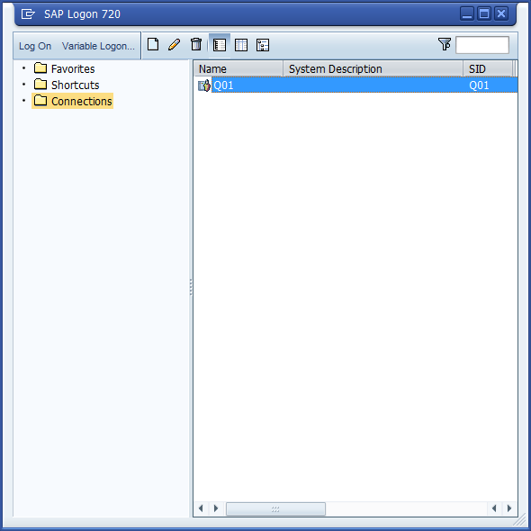
- Right Click Connections.
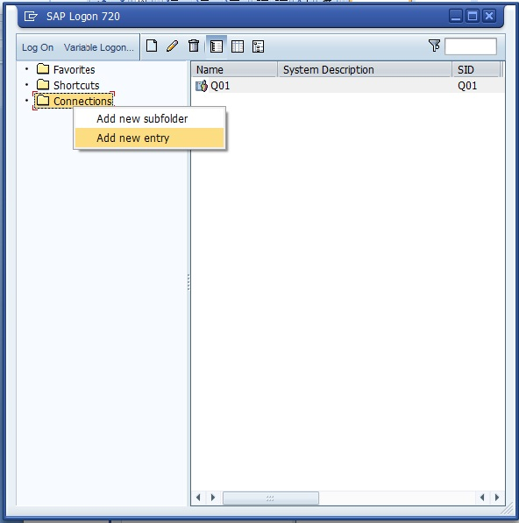
Step2. Click Add new entry

Step3. Select User Specified System and Click Next
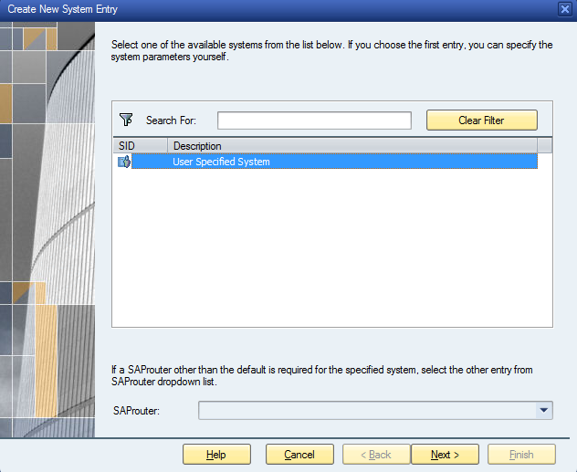
Step 4. Enter System Connection Parameters
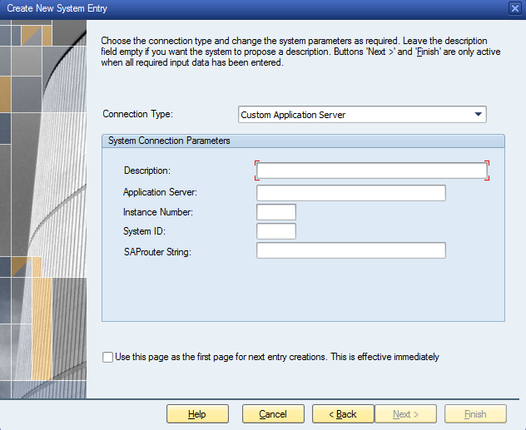
Step 5: System Connection Parameters
- Description- Q01
- Applicaion Server- 10.115.102.41
- Instance Number- 01
- SyatemId- Q01
- Connection Type – Custom Application Server
Click Ok
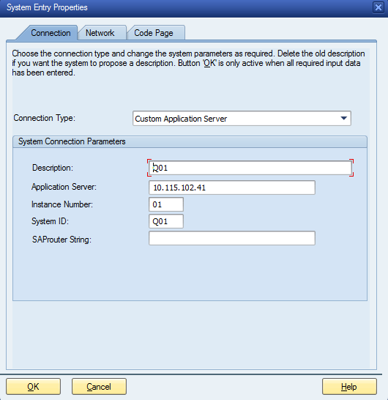

Step 6: It Shows Q01 in Right Pane
Double Click Q01
Step 7: Enter UserId: maryadr
Pwd: Apr@2013
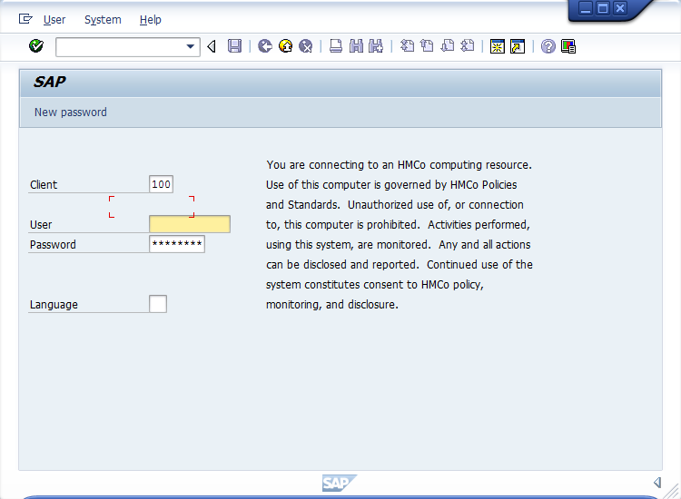
Step 8: Click Enter
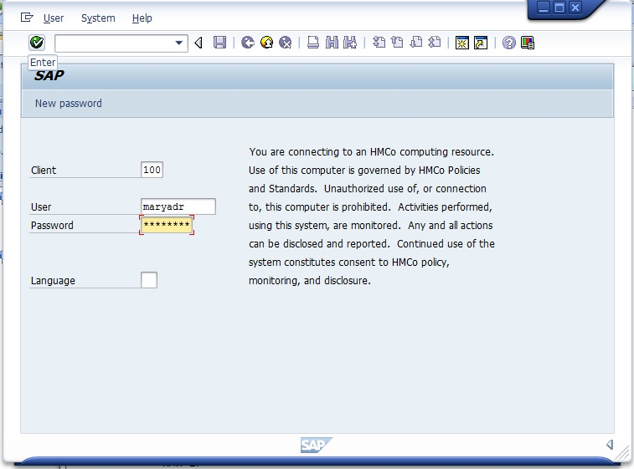
Step 9: It will show Welcome Page
